Sea of Japan Sea of Okhjotsk

East China Sea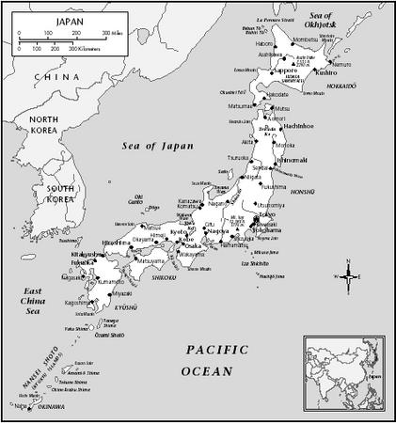Pacific Ocean
Philippine Sea

